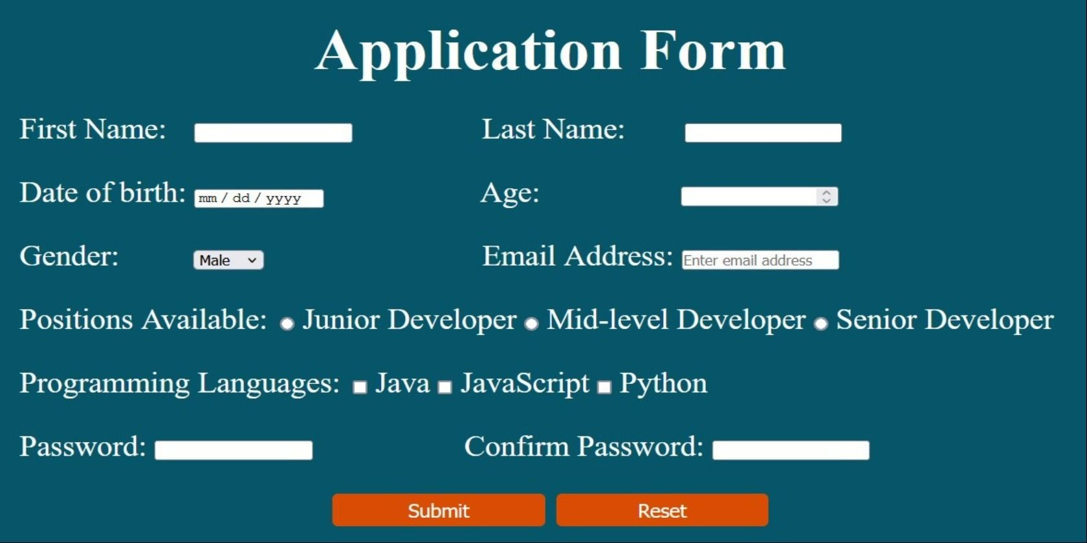

1. Age should be within 15 to 30. Date of birth selection also should have this constraint.

2, Password should have 8 or more characters.

The policy for the Password is at least one number, and one uppercase and lowercase letter.

1. Print the first name and the Last name in an alert box.
2. Print the first name and the Last name below the form.